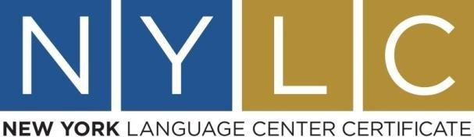

# APPLICATION FORM

**Date of Written examination Saturday:**

**Oral examination Friday: morning ** **afternoon**  

**Level: B1 ** **B2 ** **C1 **  **C2 **

|  |  |
| --- | --- |
| **FIRST NAME** |  |
| **LAST NAME** |  |
| **Father’s name** |  |
| **Date of birth** |  |
| **I.D./Passport Number** |  |
| **Telephone number**  **Mobile** |  |
| **E-mail** |  |

Please fill in your name in Latin characters as it appears on your identity card or passport. On the day of the exam you must present a valid document to prove your identity.

**Declaration**

I hereby declare that:

I accept the NYLC exam regulations, and the EDU STANDARDS Privacy Policy and I agree to my above personal information being written on the official certificate.

# Date________________Signature_______________